CYCLE-1
1.Design a Login Page.
PROGRAM:
xml:
<LinearLayout xmlns:tools="http://schemas.android.com/tools"
android:layout_width="match_parent"
android:layout_height="match_parent"
android:orientation="vertical"
xmlns:android="http://schemas.android.com/apk/res/android" >
<TextView
android:id="@+id/head"
android:layout_width="match_parent"
android:layout_height="wrap_content"
android:layout_marginTop="30dp"
android:gravity="center_horizontal"
android:padding="5dp"
android:text="Login"
android:textAlignment="center"
android:textColor="@color/colorPrimaryDark"
android:textSize="18sp" />
<EditText
android:id="@+id/usr"
android:layout_width="match_parent"
android:layout_height="wrap_content"
android:hint="Enter Username"
android:layout_marginTop="20dp"
android:layout_marginBottom="10dp"/>
<EditText
android:id="@+id/pwd"
android:layout_width="match_parent"
android:layout_height="wrap_content"
android:layout_marginTop="20dp"
android:layout_marginBottom="10dp"
android:hint="Enter Password"/>
<Button
android:id="@+id/lgnbtn"
android:layout_width="match_parent"
android:layout_height="wrap_content"
android:layout_marginTop="20dp"
android:layout_marginBottom="10dp"
android:background="@color/colorPrimary"
android:onClick="Click"
android:text="Login"
tools:background="@android:color/holo_green_dark" />
</LinearLayout>
Java:
package com.example.sjcet.login;
import android.support.v7.app.AppCompatActivity;
import android.os.Bundle;
import android.view.View;
import android.widget.Button;
import android.widget.EditText;
import android.widget.LinearLayout;
public class MainActivity extends AppCompatActivity {
EditText username,password;
Button lgnbtn;
@Override
protected void onCreate(Bundle savedInstanceState) {
super.onCreate(savedInstanceState);
setContentView(R.layout.activity_main);

username=findViewById(R.id.usr);
password=findViewById(R.id.pwd);
lgnbtn=findViewById(R.id.lgnbtn);
}
public void Click(View view) {
String user = username.getText().toString();
}
}
OUTPUT:
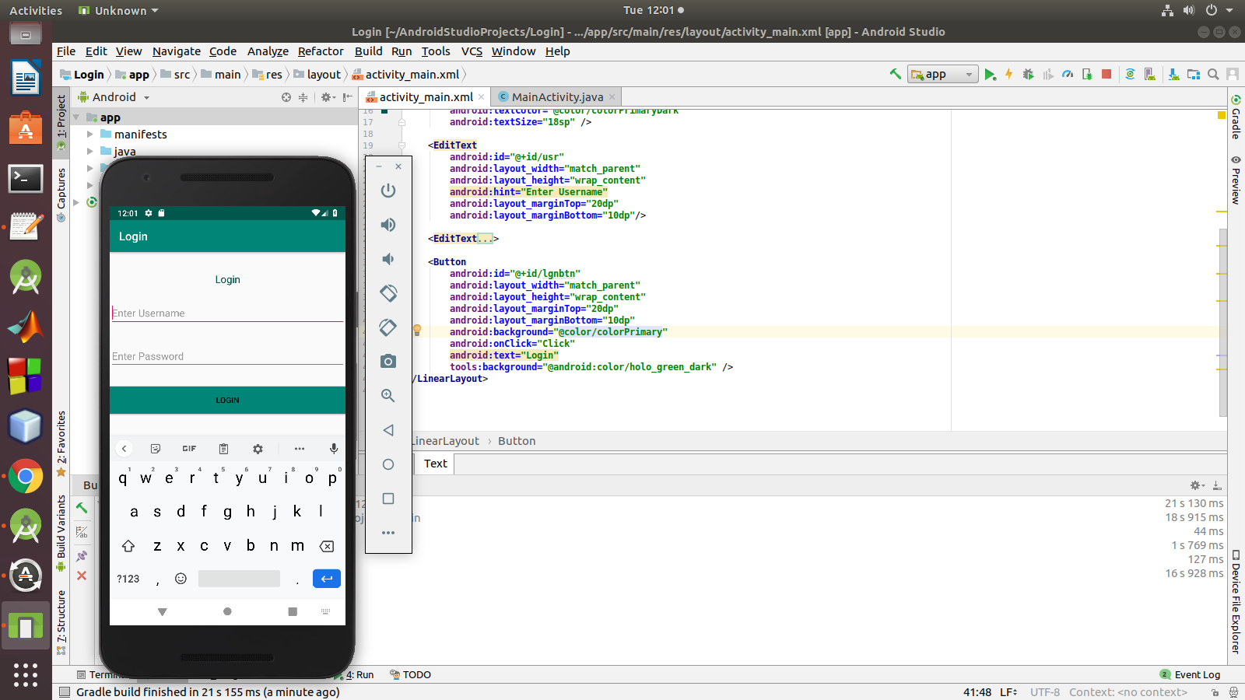

2.Change the content from EditText and print it in a TextView

PROGRAM
xml:
<LinearLayout
android:layout_height="match_parent"
android:layout_width="match_parent"
android:orientation="vertical"
xmlns:android="http://schemas.android.com/apk/res/android" >
<TextView
android:layout_width="match_parent"
android:layout_height="wrap_content"
android:layout_marginTop="30dp"
android:gravity="center_horizontal"
android:padding="5dp"
android:text="Change Content on Button Click"
android:textAlignment="center"
android:textColor="@color/colorPrimaryDark"
android:textSize="18sp"/>
<EditText
android:id="@+id/txt"
android:layout_width="match_parent"
android:layout_height="wrap_content"
android:hint="Enter Text"
android:layout_marginTop="20dp"
android:layout_marginBottom="10dp"/>
<Button
android:id="@+id/btn"
android:layout_width="match_parent"
android:layout_height="wrap_content"
android:layout_marginTop="20dp"
android:layout_marginBottom="10dp"
android:background="@color/colorPrimary"
android:onClick="click"
android:text="Change"/>
</LinearLayout>
java:
package com.example.sjcet.change_content;
import android.support.v7.app.AppCompatActivity;
import android.os.Bundle;
import android.view.View;
import android.widget.Button;
import android.widget.EditText;
public class MainActivity extends AppCompatActivity {
EditText txt;
Button btn;
@Override
protected void onCreate(Bundle savedInstanceState) {
super.onCreate(savedInstanceState);
setContentView(R.layout.activity_main);
txt= findViewById(R.id.txt);
btn= findViewById(R.id.btn);
}
public void click(View view) {
txt.setText("this is text ");
}
}
OUTPUT:

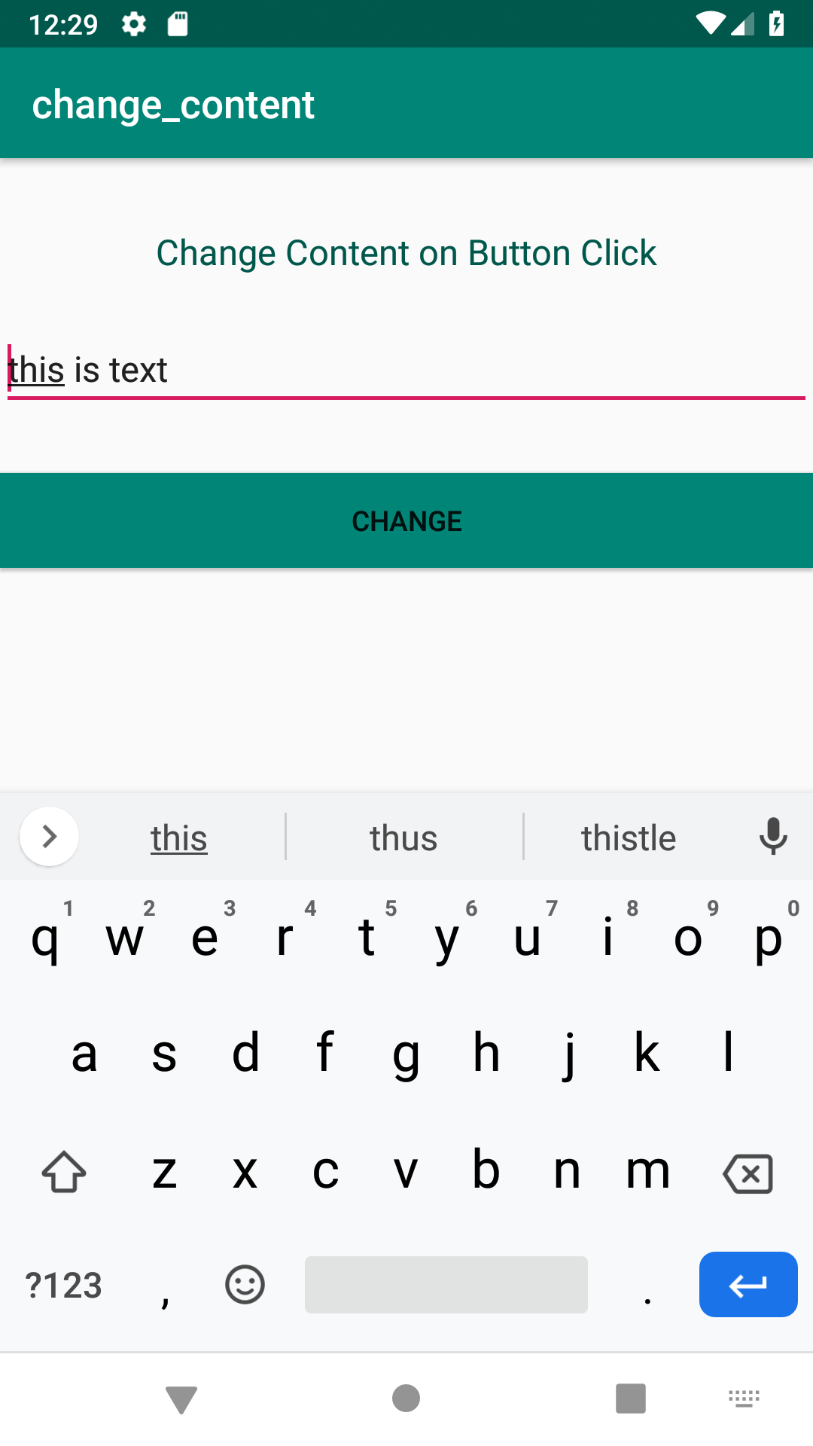

3. Read a content from EditText and print it in a TextView.

PROGRAM:
xml:
<LinearLayout
android:layout_height="match_parent"
android:layout_width="match_parent"
android:orientation="vertical"
xmlns:android="http://schemas.android.com/apk/res/android">
<EditText
android:id="@+id/text1"
android:layout_width="match_parent"
android:layout_height="wrap_content"
android:hint="Enter Text"/>
<Button
android:id="@+id/btn"
android:layout_width="match_parent"
android:layout_height="wrap_content"
android:text="Change"
android:onClick="Click"
/>
<TextView
android:id="@+id/text2"
android:layout_width="match_parent"
android:layout_height="wrap_content"
/>
</LinearLayout>
java:

package com.example.sjcet.c1_p3;
import android.support.v7.app.AppCompatActivity;
import android.os.Bundle;
import android.view.View;
import android.widget.Button;
import android.widget.EditText;
import android.widget.TextView;
public class MainActivity extends AppCompatActivity {
EditText text1;
TextView text2;
Button btn;
@Override
protected void onCreate(Bundle savedInstanceState) {
super.onCreate(savedInstanceState);
setContentView(R.layout.activity_main);
text1=(EditText)findViewById(R.id.text1);
btn=(Button)findViewById(R.id.btn);
text2=(TextView)findViewById(R.id.text2);
}
public void Click(View view) {
String content= text1.getText().toString();
text2.setText(content);
}
}
OUTPUT:

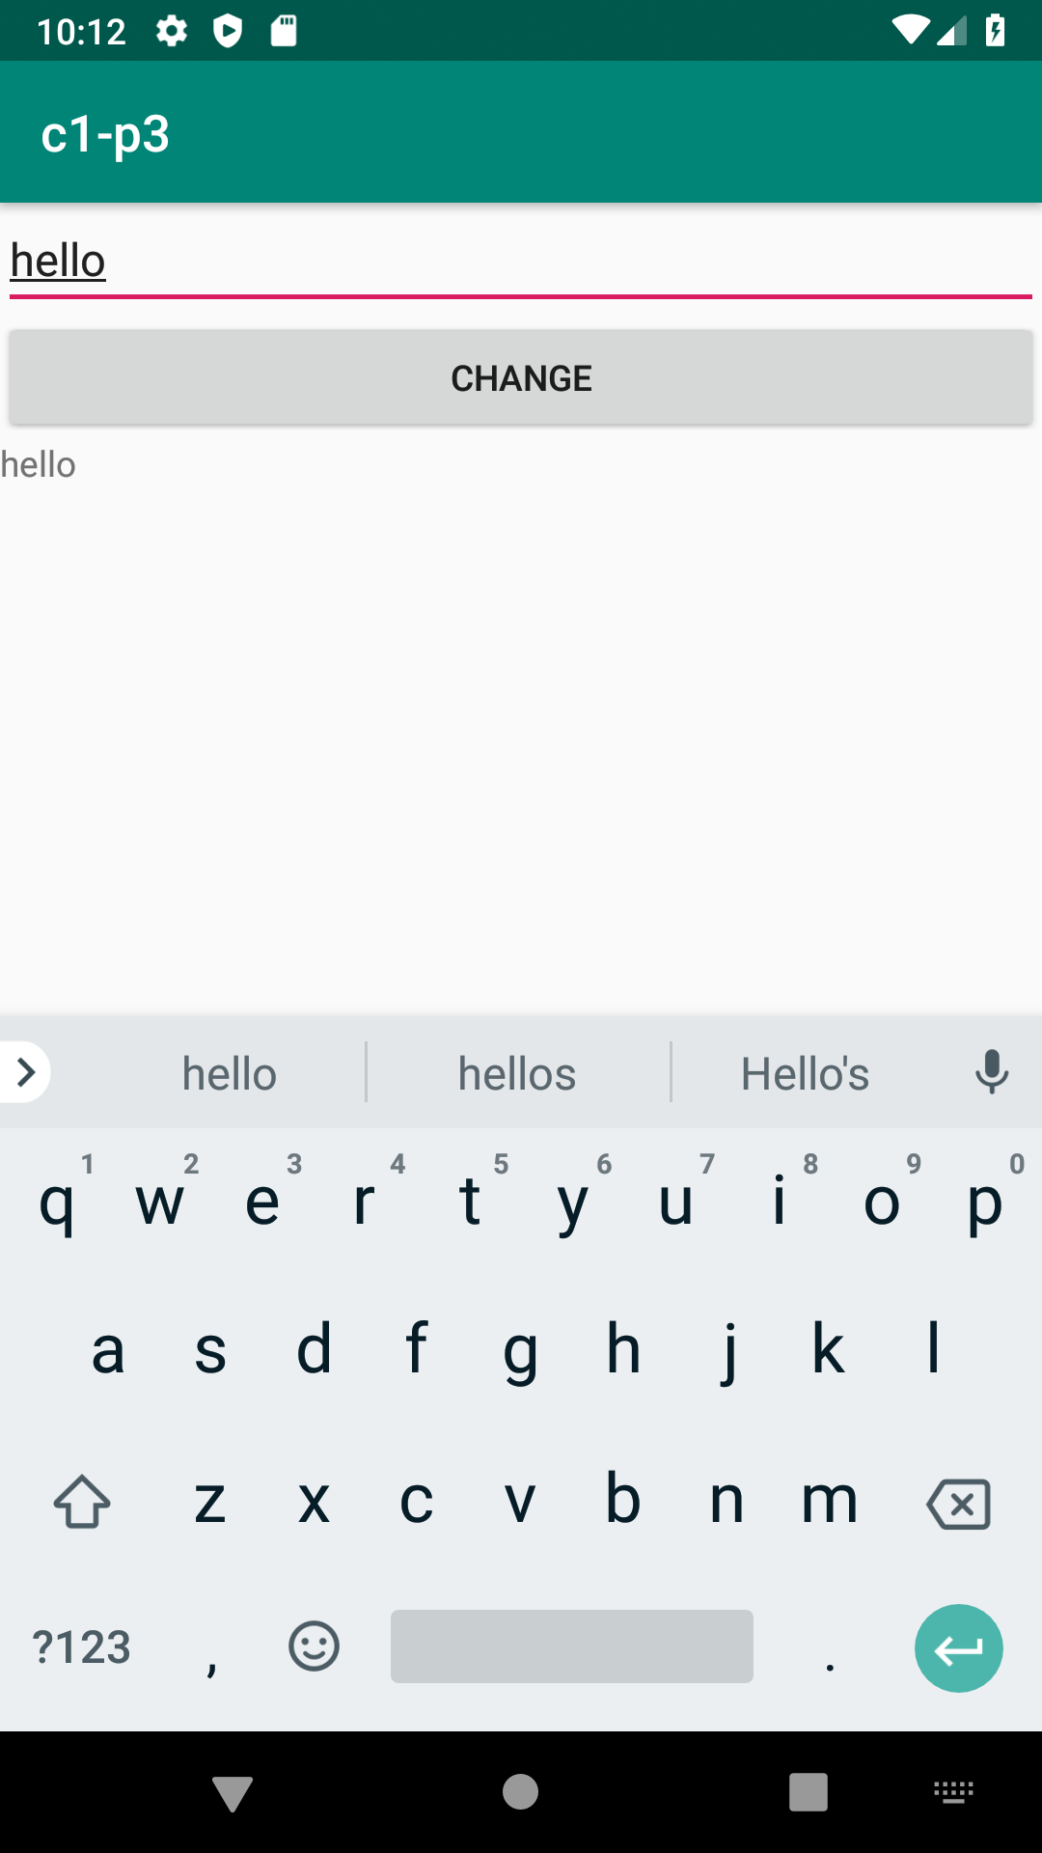

4.Change the background color on a button click.
PROGRAM:
XML:
<LinearLayout
android:id="@+id/p1"
android:layout_width="match_parent"
android:layout_height="match_parent"
android:orientation="vertical"
android:gravity="center"
xmlns:android="http://schemas.android.com/apk/res/android">
<Button
android:id="@+id/cng"
android:layout_width="wrap_content"
android:layout_height="wrap_content"
android:gravity="center"
android:onClick="click"
android:text="Change" />
</LinearLayout>
JAVA:
package com.example.sjcet.bgcolor;
import android.widget.Button;
import android.support.v7.app.AppCompatActivity;
import android.os.Bundle;
import android.view.View;
public class MainActivity extends AppCompatActivity {
Button btn;
View v;
@Override
protected void onCreate(Bundle savedInstanceState) {
super.onCreate(savedInstanceState);
setContentView(R.layout.activity_main);
btn=findViewById(R.id.cng);
v = this.getWindow().getDecorView();
}
public void click(View view) {
v.setBackgroundResource(android.R.color.holo_blue_dark);
}
}
OUTPUT:
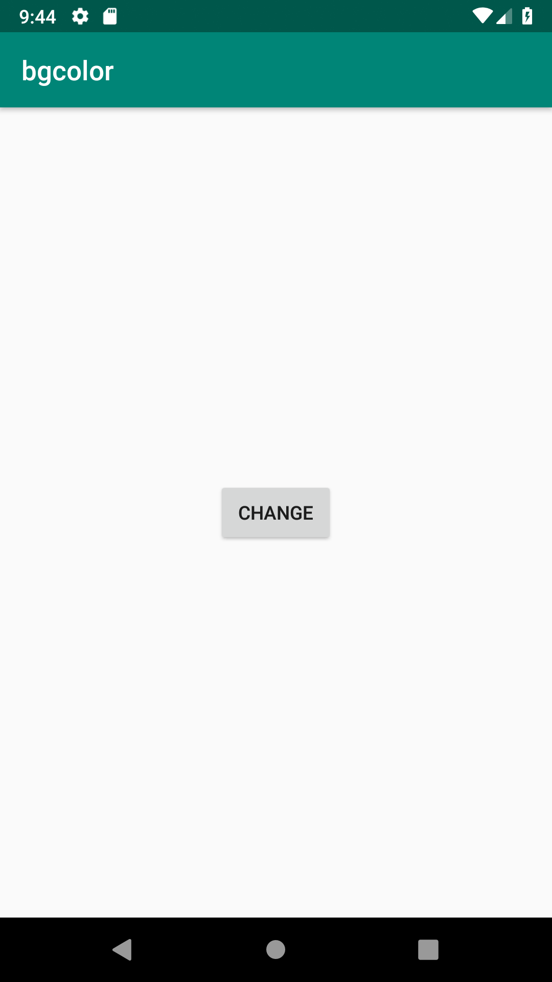
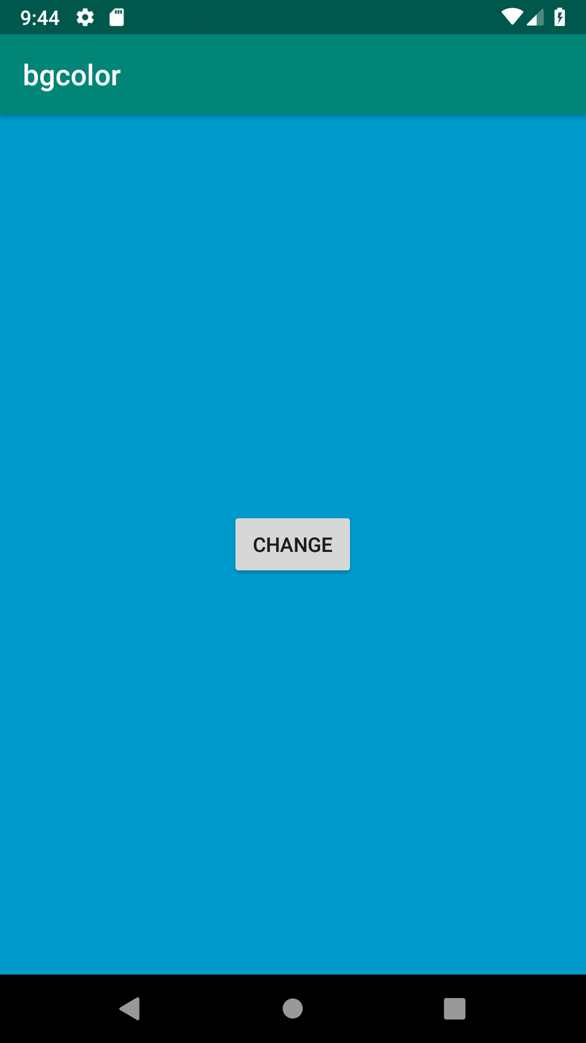

5.Create a sample calculator
PROGRAM:
XML:
<?xml version="1.0" encoding="utf-8"?>
<RelativeLayout xmlns:android="http://schemas.android.com/apk/res/android"
xmlns:tools="http://schemas.android.com/tools"
android:id="@+id/relative1"
android:layout_width="match_parent"
android:layout_height="match_parent"
tools:context=".MainActivity">
<EditText
android:id="@+id/edt1"
android:layout_width="match_parent"
android:layout_height="wrap_content" />
<Button
android:id="@+id/button1"
style="?android:attr/buttonStyleSmall"
android:layout_width="wrap_content"
android:layout_height="wrap_content"
android:layout_alignEnd="@+id/button4"
android:layout_alignRight="@+id/button4"
android:layout_below="@+id/edt1"
android:layout_marginTop="94dp"
android:text="1" />
<Button
android:id="@+id/button2"
style="?android:attr/buttonStyleSmall"
android:layout_width="wrap_content"
android:layout_height="wrap_content"
android:layout_alignTop="@+id/button1"
android:layout_toLeftOf="@+id/button3"
android:layout_toStartOf="@+id/button3"
android:text="2" />
<Button
android:id="@+id/button3"
style="?android:attr/buttonStyleSmall"
android:layout_width="wrap_content"
android:layout_height="wrap_content"
android:layout_alignTop="@+id/button2"
android:layout_centerHorizontal="true"
android:text="3" />
<Button
android:id="@+id/button4"
style="?android:attr/buttonStyleSmall"
android:layout_width="wrap_content"
android:layout_height="wrap_content"
android:layout_below="@+id/button1"
android:layout_toLeftOf="@+id/button2"
android:text="4" />
<Button
android:id="@+id/button5"
style="?android:attr/buttonStyleSmall"
android:layout_width="wrap_content"
android:layout_height="wrap_content"
android:layout_alignBottom="@+id/button4"
android:layout_alignLeft="@+id/button2"
android:layout_alignStart="@+id/button2"
android:text="5" />
<Button
android:id="@+id/button6"
style="?android:attr/buttonStyleSmall"
android:layout_width="wrap_content"
android:layout_height="wrap_content"
android:layout_alignLeft="@+id/button3"
android:layout_alignStart="@+id/button3"
android:layout_below="@+id/button3"
android:text="6" />
<Button
android:id="@+id/button7"
style="?android:attr/buttonStyleSmall"
android:layout_width="wrap_content"
android:layout_height="wrap_content"
android:layout_below="@+id/button4"
android:layout_toLeftOf="@+id/button2"
android:text="7" />
<Button
android:id="@+id/button8"
style="?android:attr/buttonStyleSmall"
android:layout_width="wrap_content"
android:layout_height="wrap_content"
android:layout_alignLeft="@+id/button5"
android:layout_alignStart="@+id/button5"
android:layout_below="@+id/button5"
android:text="8" />
<Button
android:id="@+id/button9"
style="?android:attr/buttonStyleSmall"
android:layout_width="wrap_content"
android:layout_height="wrap_content"
android:layout_alignLeft="@+id/button6"
android:layout_alignStart="@+id/button6"
android:layout_below="@+id/button6"
android:text="9" />
<Button
android:id="@+id/buttonadd"
style="?android:attr/buttonStyleSmall"
android:layout_width="wrap_content"
android:layout_height="wrap_content"
android:layout_alignEnd="@+id/edt1"
android:layout_alignRight="@+id/edt1"
android:layout_alignTop="@+id/button3"
android:layout_marginLeft="46dp"
android:layout_marginStart="46dp"
android:layout_toRightOf="@+id/button3"
android:text="+" />
<Button
android:id="@+id/buttonsub"
style="?android:attr/buttonStyleSmall"
android:layout_width="wrap_content"
android:layout_height="wrap_content"
android:layout_alignEnd="@+id/buttonadd"
android:layout_alignLeft="@+id/buttonadd"
android:layout_alignRight="@+id/buttonadd"
android:layout_alignStart="@+id/buttonadd"
android:layout_below="@+id/buttonadd"
android:text="-" />
<Button
android:id="@+id/buttonmul"
style="?android:attr/buttonStyleSmall"
android:layout_width="wrap_content"
android:layout_height="wrap_content"
android:layout_alignLeft="@+id/buttonsub"
android:layout_alignParentEnd="true"
android:layout_alignParentRight="true"
android:layout_alignStart="@+id/buttonsub"
android:layout_below="@+id/buttonsub"
android:text="*" />
<Button
android:id="@+id/button10"
style="?android:attr/buttonStyleSmall"
android:layout_width="wrap_content"
android:layout_height="wrap_content"
android:layout_below="@+id/button7"
android:layout_toLeftOf="@+id/button2"
android:text="." />
<Button
android:id="@+id/button0"
style="?android:attr/buttonStyleSmall"
android:layout_width="wrap_content"
android:layout_height="wrap_content"
android:layout_alignLeft="@+id/button8"
android:layout_alignStart="@+id/button8"
android:layout_below="@+id/button8"
android:text="0" />
<Button
android:id="@+id/buttonC"
style="?android:attr/buttonStyleSmall"
android:layout_width="wrap_content"
android:layout_height="wrap_content"
android:layout_alignLeft="@+id/button9"
android:layout_alignStart="@+id/button9"
android:layout_below="@+id/button9"
android:text="C" />
<Button
android:id="@+id/buttondiv"
style="?android:attr/buttonStyleSmall"
android:layout_width="wrap_content"
android:layout_height="wrap_content"
android:layout_alignEnd="@+id/buttonmul"
android:layout_alignLeft="@+id/buttonmul"
android:layout_alignRight="@+id/buttonmul"
android:layout_alignStart="@+id/buttonmul"
android:layout_below="@+id/buttonmul"
android:text="/" />
<Button
android:id="@+id/buttoneql"
android:layout_width="wrap_content"
android:layout_height="wrap_content"
android:layout_alignEnd="@+id/buttondiv"
android:layout_alignLeft="@+id/button10"
android:layout_alignRight="@+id/buttondiv"
android:layout_alignStart="@+id/button10"
android:layout_below="@+id/button0"
android:layout_marginTop="37dp"
android:text="=" />
</RelativeLayout>
JAVA:
package com.example.sjcet.calculator;
import android.support.v7.app.AppCompatActivity;
import android.os.Bundle;
import android.view.View;
import android.widget.Button;
import android.widget.EditText;
public class MainActivity extends AppCompatActivity {
Button button0, button1, button2, button3, button4, button5, button6,
button7, button8, button9, buttonAdd, buttonSub, buttonDivision,
buttonMul, button10, buttonC, buttonEqual;
EditText crunchifyEditText;
float mValueOne, mValueTwo;
boolean crunchifyAddition, mSubtract, crunchifyMultiplication, crunchifyDivision;
@Override
protected void onCreate(Bundle savedInstanceState) {
super.onCreate(savedInstanceState);
setContentView(R.layout.activity_main);
button0 = (Button) findViewById(R.id.button0);
button1 = (Button) findViewById(R.id.button1);
button2 = (Button) findViewById(R.id.button2);
button3 = (Button) findViewById(R.id.button3);
button4 = (Button) findViewById(R.id.button4);
button5 = (Button) findViewById(R.id.button5);
button6 = (Button) findViewById(R.id.button6);
button7 = (Button) findViewById(R.id.button7);
button8 = (Button) findViewById(R.id.button8);
button9 = (Button) findViewById(R.id.button9);
button10 = (Button) findViewById(R.id.button10);
buttonAdd = (Button) findViewById(R.id.buttonadd);
buttonSub = (Button) findViewById(R.id.buttonsub);
buttonMul = (Button) findViewById(R.id.buttonmul);
buttonDivision = (Button) findViewById(R.id.buttondiv);
buttonC = (Button) findViewById(R.id.buttonC);
buttonEqual = (Button) findViewById(R.id.buttoneql);
crunchifyEditText = (EditText) findViewById(R.id.edt1);
button1.setOnClickListener(new View.OnClickListener() {
@Override
public void onClick(View v) {
crunchifyEditText.setText(crunchifyEditText.getText() + "1");
}
});
button2.setOnClickListener(new View.OnClickListener() {
@Override
public void onClick(View v) {
crunchifyEditText.setText(crunchifyEditText.getText() + "2");
}
});
button3.setOnClickListener(new View.OnClickListener() {
@Override
public void onClick(View v) {
crunchifyEditText.setText(crunchifyEditText.getText() + "3");
}
});
button4.setOnClickListener(new View.OnClickListener() {
@Override
public void onClick(View v) {
crunchifyEditText.setText(crunchifyEditText.getText() + "4");
}
});
button5.setOnClickListener(new View.OnClickListener() {
@Override
public void onClick(View v) {
crunchifyEditText.setText(crunchifyEditText.getText() + "5");
}
});
button6.setOnClickListener(new View.OnClickListener() {
@Override
public void onClick(View v) {
crunchifyEditText.setText(crunchifyEditText.getText() + "6");
}
});
button7.setOnClickListener(new View.OnClickListener() {
@Override
public void onClick(View v) {
crunchifyEditText.setText(crunchifyEditText.getText() + "7");
}
});
button8.setOnClickListener(new View.OnClickListener() {
@Override
public void onClick(View v) {
crunchifyEditText.setText(crunchifyEditText.getText() + "8");
}
});
button9.setOnClickListener(new View.OnClickListener() {
@Override
public void onClick(View v) {
crunchifyEditText.setText(crunchifyEditText.getText() + "9");
}
});
button0.setOnClickListener(new View.OnClickListener() {
@Override
public void onClick(View v) {
crunchifyEditText.setText(crunchifyEditText.getText() + "0");
}
});
buttonAdd.setOnClickListener(new View.OnClickListener() {
@Override
public void onClick(View v) {
if (crunchifyEditText == null) {
crunchifyEditText.setText("");
} else {
mValueOne = Float.parseFloat(crunchifyEditText.getText() + "");
crunchifyAddition = true;
crunchifyEditText.setText(null);
}
}
});
buttonSub.setOnClickListener(new View.OnClickListener() {
@Override
public void onClick(View v) {
mValueOne = Float.parseFloat(crunchifyEditText.getText() + "");
mSubtract = true;
crunchifyEditText.setText(null);
}
});
buttonMul.setOnClickListener(new View.OnClickListener() {
@Override
public void onClick(View v) {
mValueOne = Float.parseFloat(crunchifyEditText.getText() + "");
crunchifyMultiplication = true;
crunchifyEditText.setText(null);
}
});
buttonDivision.setOnClickListener(new View.OnClickListener() {
@Override
public void onClick(View v) {
mValueOne = Float.parseFloat(crunchifyEditText.getText() + "");
crunchifyDivision = true;
crunchifyEditText.setText(null);
}
});
buttonEqual.setOnClickListener(new View.OnClickListener() {
@Override
public void onClick(View v) {
mValueTwo = Float.parseFloat(crunchifyEditText.getText() + "");
if (crunchifyAddition == true) {
crunchifyEditText.setText(mValueOne + mValueTwo + "");
crunchifyAddition = false;
}
if (mSubtract == true) {
crunchifyEditText.setText(mValueOne - mValueTwo + "");
mSubtract = false;
}
if (crunchifyMultiplication == true) {
crunchifyEditText.setText(mValueOne * mValueTwo + "");
crunchifyMultiplication = false;
}
if (crunchifyDivision == true) {
crunchifyEditText.setText(mValueOne / mValueTwo + "");
crunchifyDivision = false;
}
}
});
buttonC.setOnClickListener(new View.OnClickListener() {
@Override
public void onClick(View v) {
crunchifyEditText.setText("");
}
});
button10.setOnClickListener(new View.OnClickListener() {
@Override
public void onClick(View v) {
crunchifyEditText.setText(crunchifyEditText.getText() + ".");
}
});
}
}
OUTPUT:
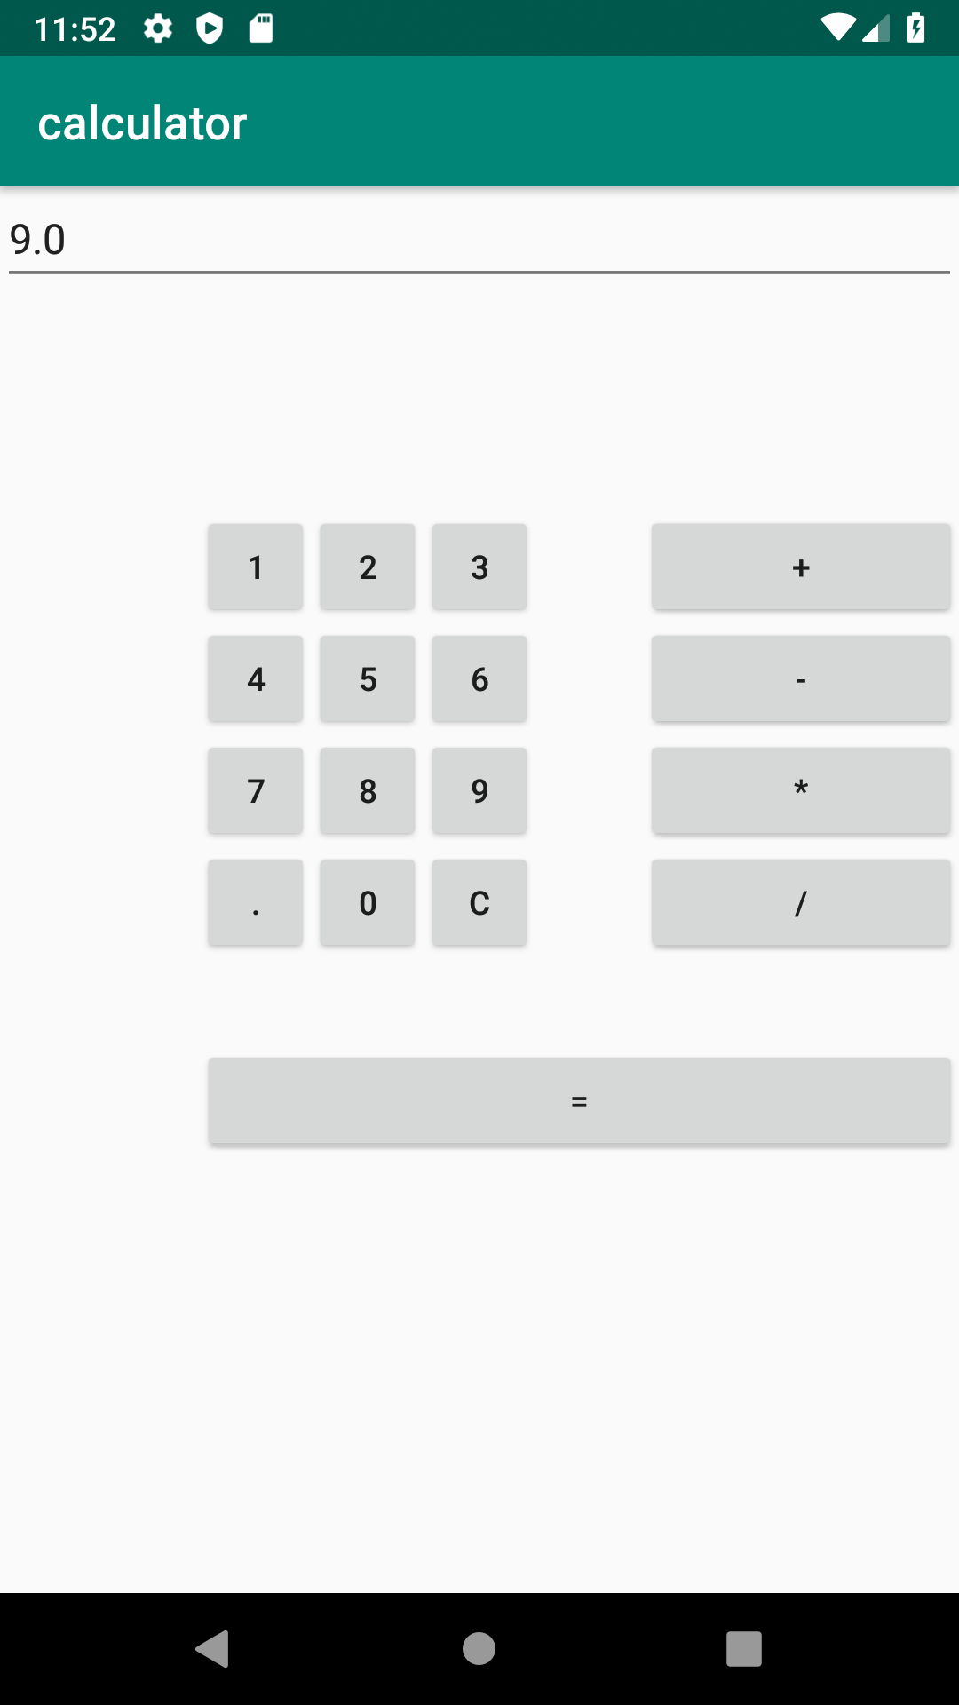

CYCLE-2
1.Create 2 activities, from the first activity move to the second activity in a button click(use Intent).
PROGRAM
Activity1:
XML:
LinearLayout
android:id="@+id/p1"
android:layout_width="match_parent"
android:layout_height="match_parent"
android:orientation="vertical"
android:gravity="center"
xmlns:android="http://schemas.android.com/apk/res/android">
<Button
android:id="@+id/btn"
android:layout_width="wrap_content"
android:layout_height="wrap_content"
android:gravity="center"
android:onClick="click"
android:text="Click"/>
</LinearLayout>
JAVA:
package com.example.sjcet.c2_p1;
import android.support.v7.app.AppCompatActivity;
import android.os.Bundle;
import android.view.View;
import android.content.Intent;
import android.widget.Button;
public class MainActivity extends AppCompatActivity {
Button btn;
@Override
protected void onCreate(Bundle savedInstanceState) {
super.onCreate(savedInstanceState);
setContentView(R.layout.activity_main);
btn = findViewById(R.id.btn);
}
public void click(View view) {
Opennewactivity();
}
public void Opennewactivity()
{
Intent intent=new Intent(this,Main2Activity.class);
startActivity(intent);
}
}
Activity2:
XML:
<?xml version="1.0" encoding="utf-8"?>
<android.support.constraint.ConstraintLayout xmlns:android="http://schemas.android.com/apk/res/android"
xmlns:app="http://schemas.android.com/apk/res-auto"
xmlns:tools="http://schemas.android.com/tools"
android:layout_width="match_parent"
android:layout_height="match_parent"
android:layout_gravity="center"
tools:context=".Main2Activity">
<TextView
android:layout_width="wrap_content"
android:layout_height="wrap_content"
android:gravity="center"
android:text="activity 2"
tools:layout_editor_absoluteX="164dp"
tools:layout_editor_absoluteY="237dp" />
</android.support.constraint.ConstraintLayout>
JAVA:
package com.example.sjcet.c2_p1;
import android.support.v7.app.AppCompatActivity;
import android.os.Bundle;
public class Main2Activity extends AppCompatActivity {
@Override
protected void onCreate(Bundle savedInstanceState) {
super.onCreate(savedInstanceState);
setContentView(R.layout.activity_main2);
}
}
OUTPUT:
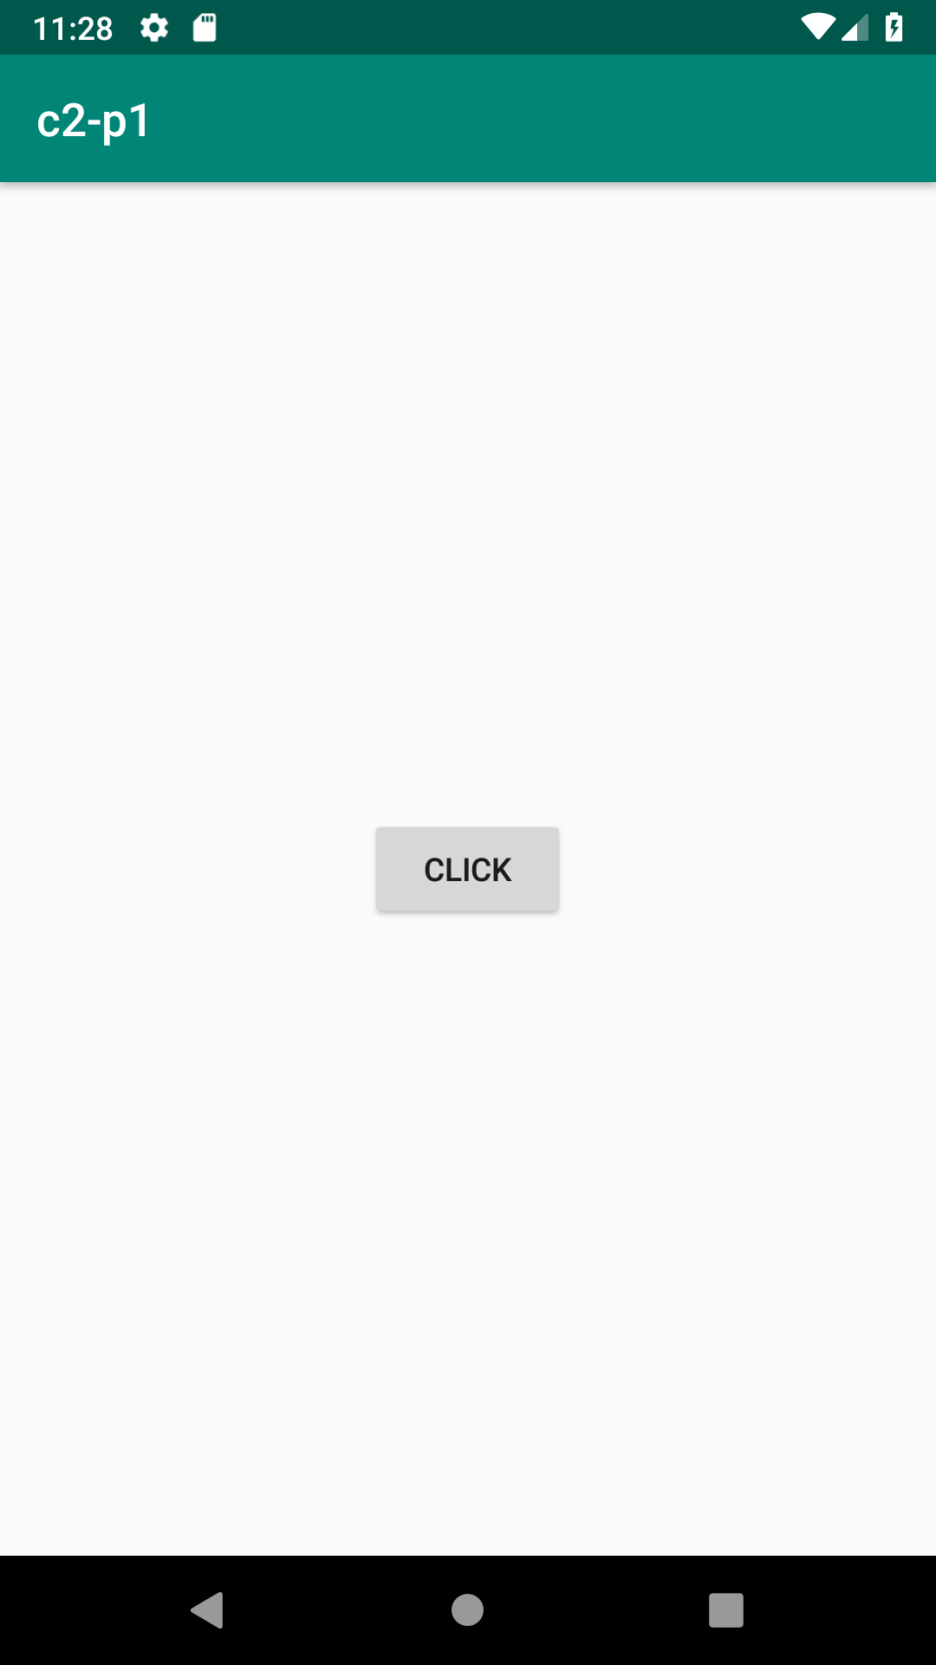
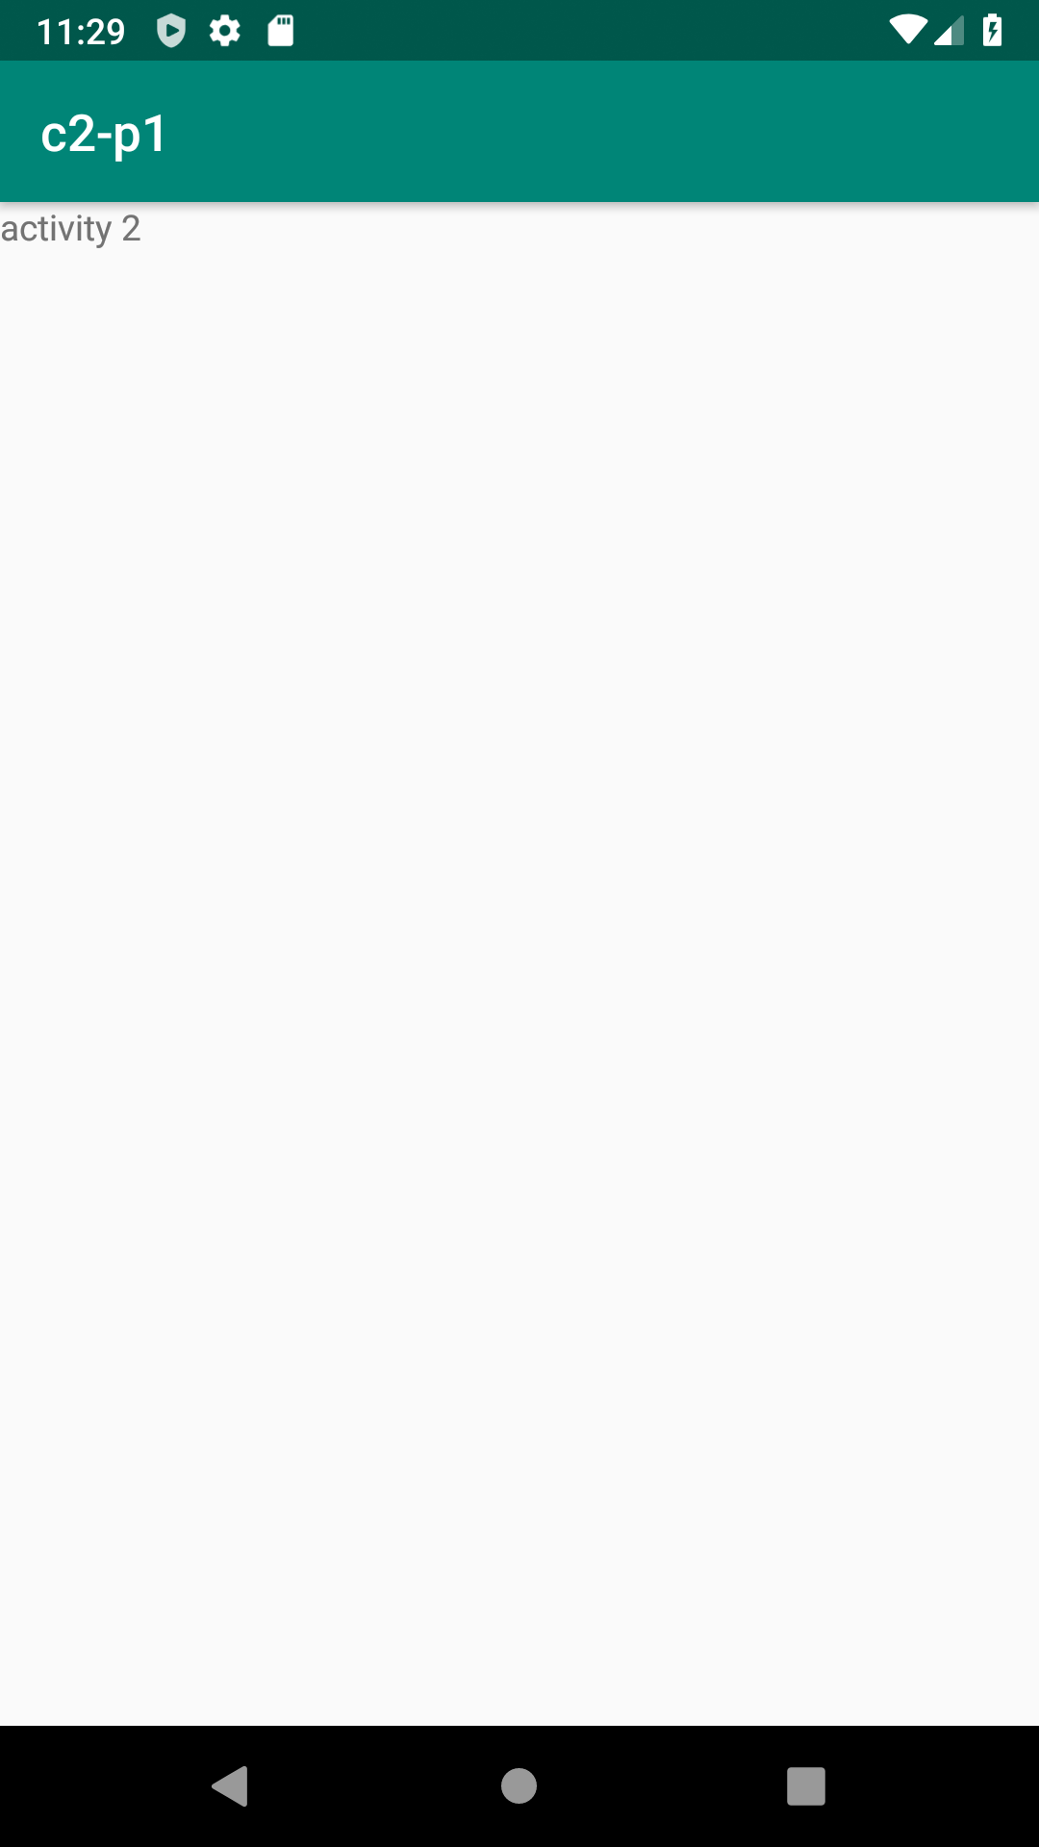

2.Create an activity and move to facebook login page on button click.
PROGRAM
XML:
<LinearLayout
android:layout_width="match_parent"
android:layout_height="match_parent"
android:orientation="vertical"
android:layout_gravity="center"
xmlns:android="http://schemas.android.com/apk/res/android" >
<Button
android:id="@+id/btn"
android:layout_width="match_parent"
android:layout_height="wrap_content"
android:gravity="center"
android:layout_gravity="center"
android:text="Click Here to Login"
android:onClick="click"/>
</LinearLayout>
JAVA:
package com.example.sjcet.c2p2;
import android.content.Intent;
import android.support.v7.app.AppCompatActivity;
import android.os.Bundle;
import android.view.View;
import android.widget.Button;
import android.net.Uri;
public class MainActivity extends AppCompatActivity {
Button snd;
@Override
protected void onCreate(Bundle savedInstanceState) {
super.onCreate(savedInstanceState);
setContentView(R.layout.activity_main);
setContentView(R.layout.activity_main);
snd=findViewById(R.id.btn);
}
public void click(View view) {
Intent intent = new Intent(Intent.ACTION_VIEW,Uri.parse("http://www.facebook.com"));
startActivity(intent);
}
}
OUTPUT

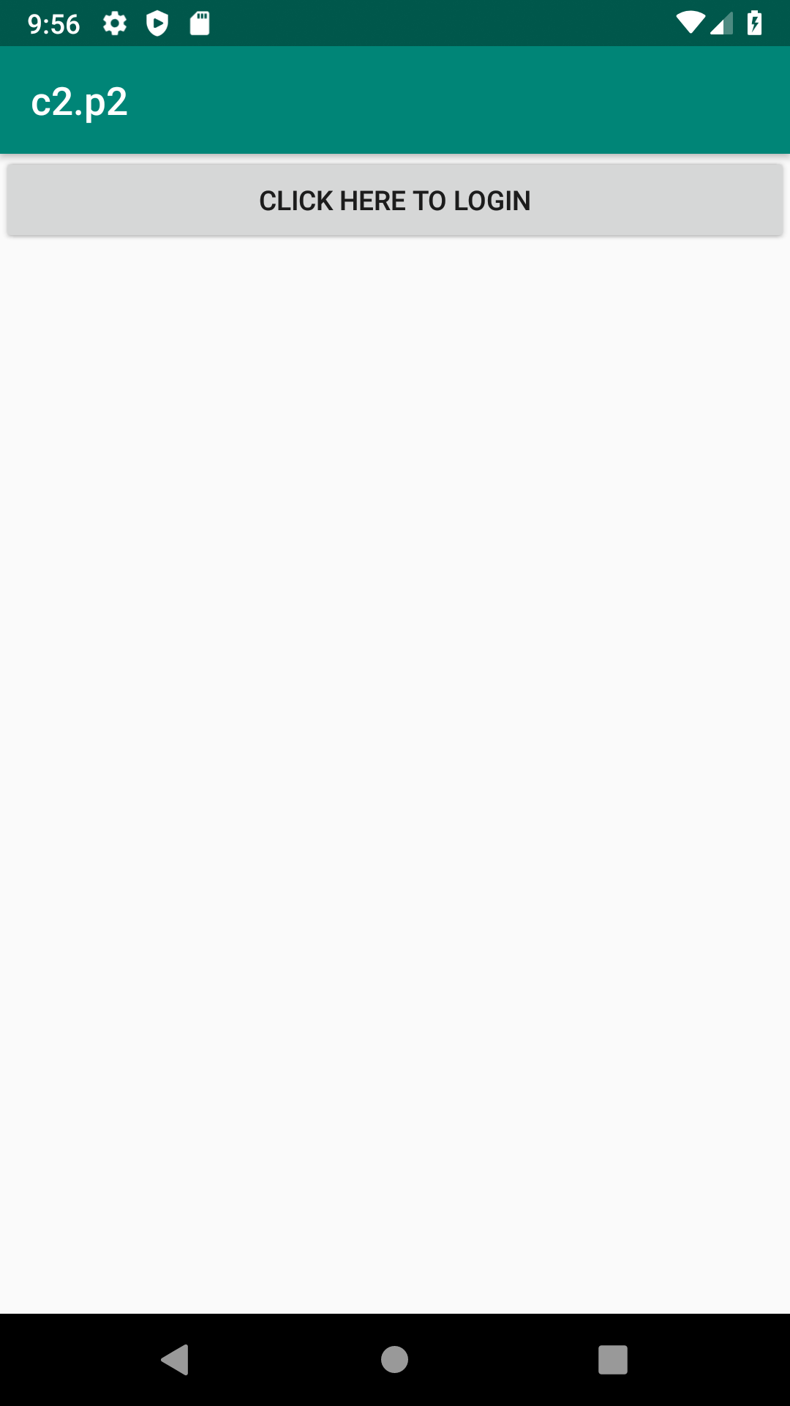
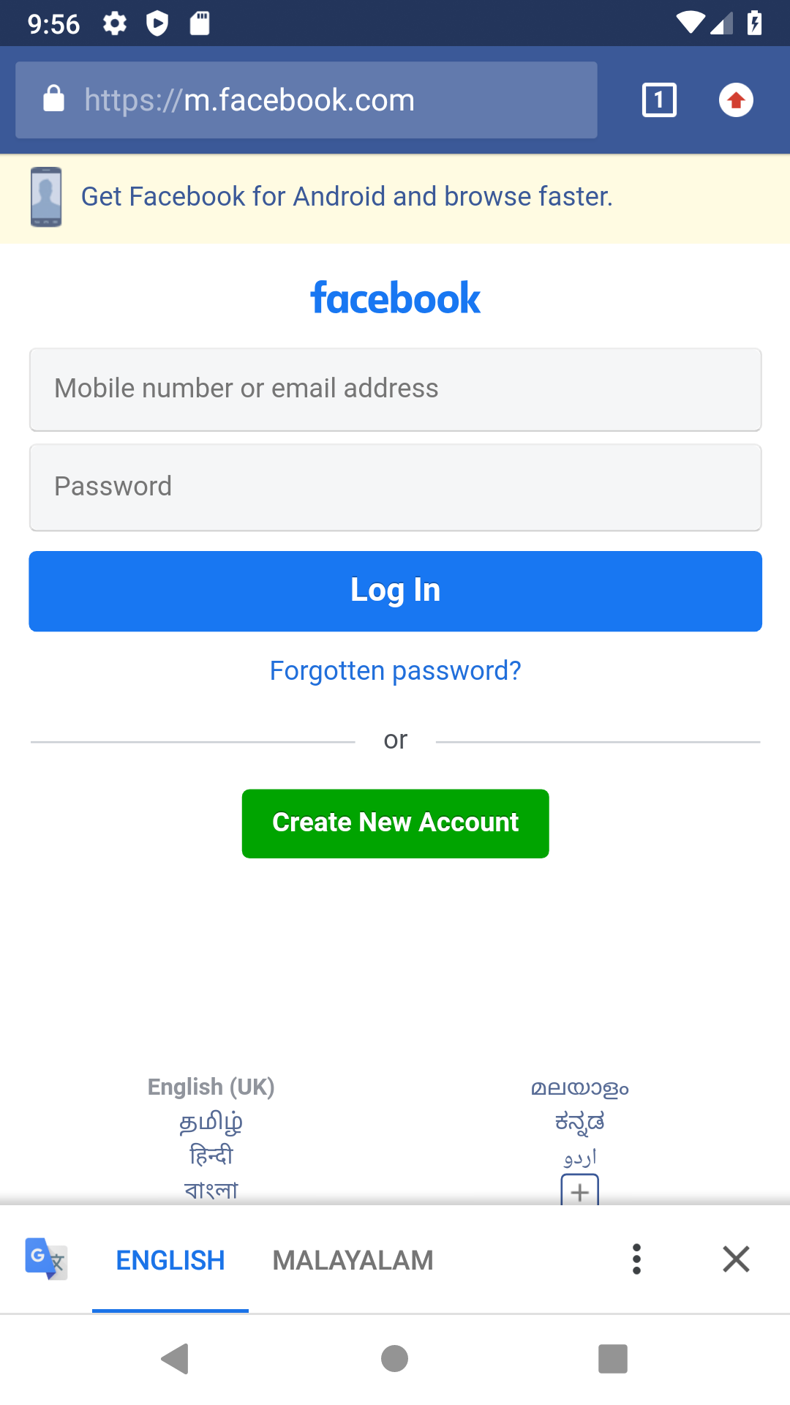

3.Read message in first activity and pass it on to the second activity on a button click.
PROGRAM:
XML:
<LinearLayout
android:layout_height="match_parent"
android:layout_width="match_parent"
android:orientation="vertical"
android:layout_gravity="center"
xmlns:android="http://schemas.android.com/apk/res/android" >
<EditText
android:id="@+id/msg"
android:layout_width="match_parent"
android:layout_height="wrap_content"
android:hint="Enter Message" />
<Button
android:id="@+id/snd"
android:layout_width="wrap_content"
android:layout_height="wrap_content"
android:text="Send"
android:layout_gravity="center"
android:onClick="click"/>
</LinearLayout>
JAVA:
package com.example.sjcet.c2_p2;
import android.content.Intent;
import android.support.v7.app.AppCompatActivity;
import android.os.Bundle;
import android.view.View;
import android.widget.Button;
import android.widget.TextView;
public class MainActivity extends AppCompatActivity {
TextView msg;
Button snd;
@Override
protected void onCreate(Bundle savedInstanceState) {
super.onCreate(savedInstanceState);
setContentView(R.layout.activity_main);
msg=findViewById(R.id.msg);
snd=findViewById(R.id.snd);
}
public void click(View view) {
String str = msg.getText().toString();
Intent intent=new Intent(getApplicationContext(),Main2Activity.class);
intent.putExtra("Message_Key",str);
startActivity(intent);
}
}
XML:
<LinearLayout android:layout_height="match_parent"
android:layout_width="match_parent"
android:orientation="vertical"
xmlns:android="http://schemas.android.com/apk/res/android" >
<TextView
android:id="@+id/rcv"
android:layout_width="match_parent"
android:layout_height="wrap_content"
android:gravity="center"/>
</LinearLayout>
JAVA:
package com.example.sjcet.c2_p2;
import android.content.Intent;
import android.support.v7.app.AppCompatActivity;
import android.os.Bundle;
import android.widget.TextView;
public class Main2Activity extends AppCompatActivity {
TextView rcv;
@Override
protected void onCreate(Bundle savedInstanceState) {
super.onCreate(savedInstanceState);
setContentView(R.layout.activity_main2);
rcv=findViewById(R.id.rcv);
Intent intent = getIntent();
String str = intent.getStringExtra("Message_Key");
// display the string into textView
rcv.setText(str);
}
}
OUTPUT:
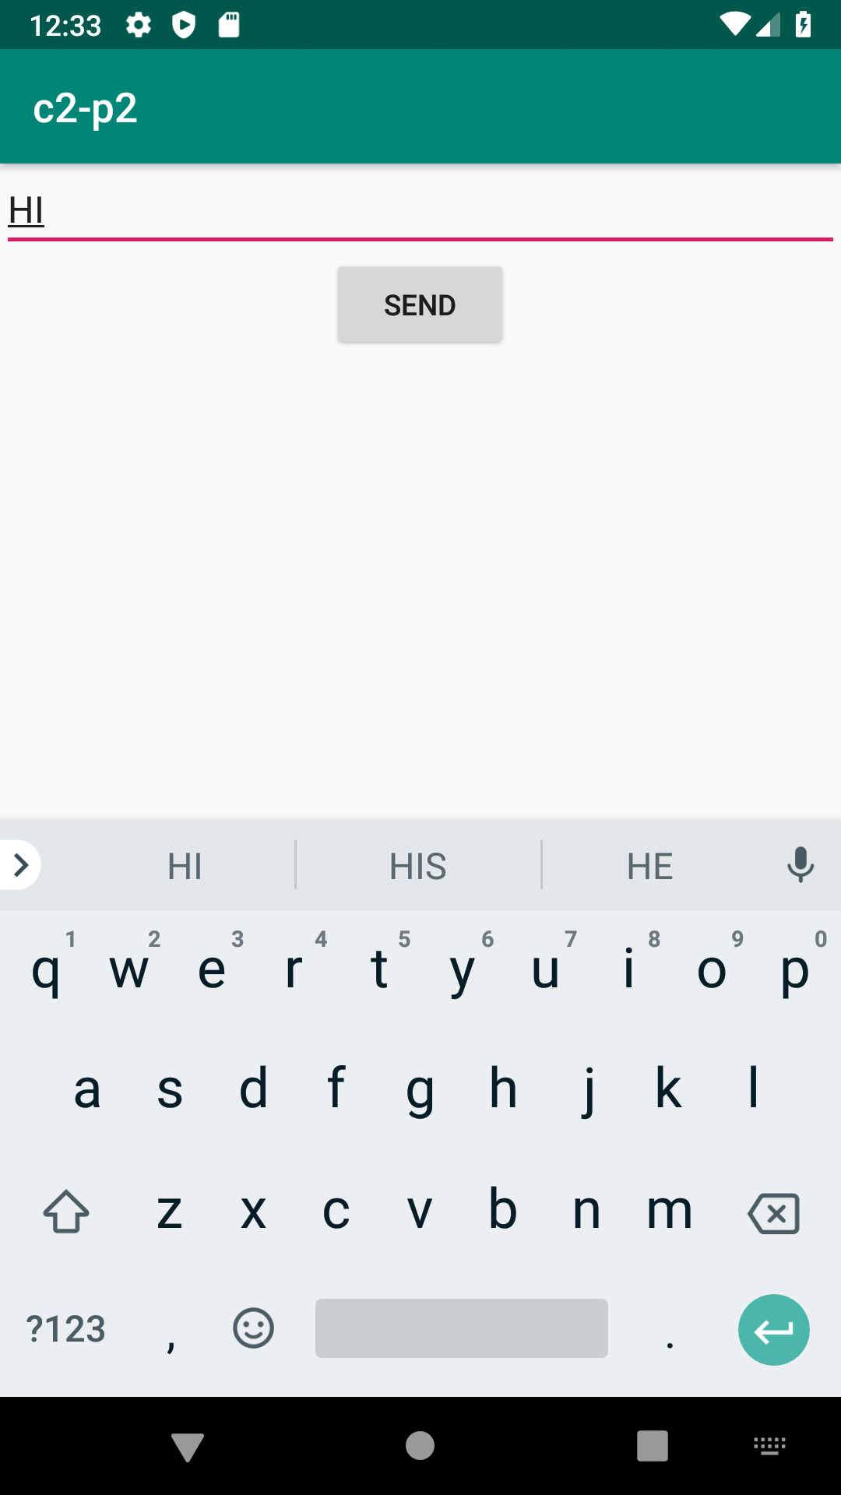
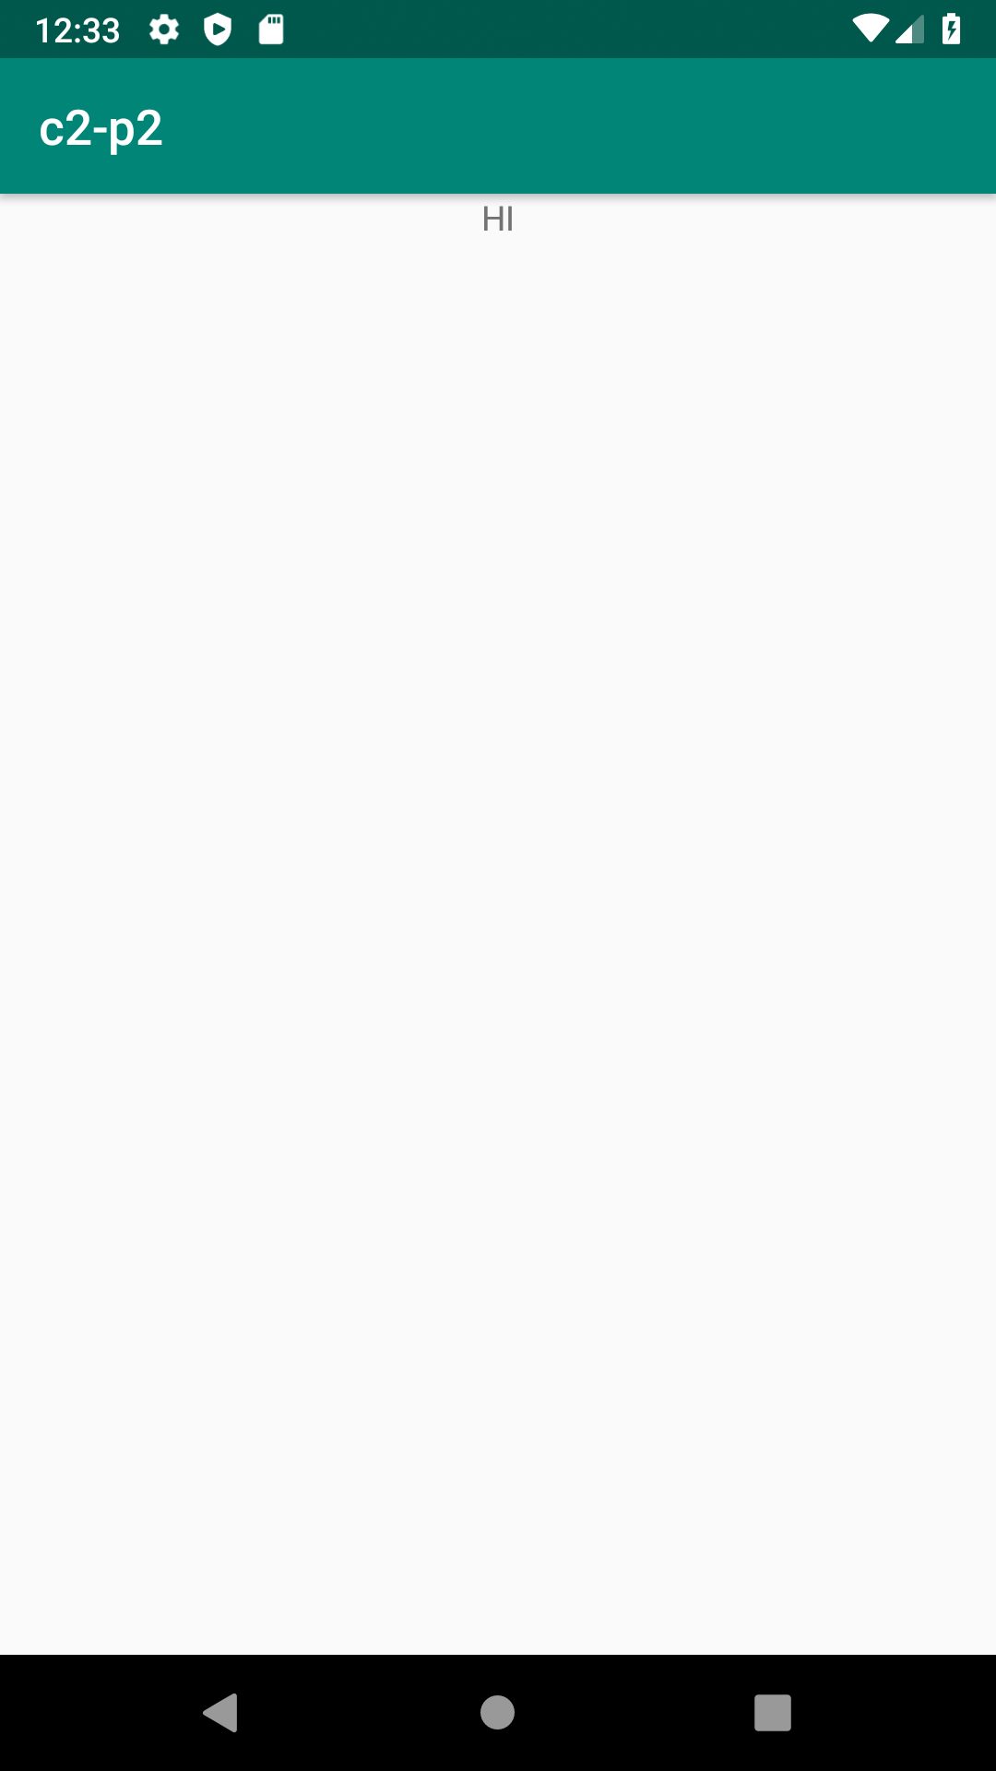

4.Create registration page with full validation and pass the information to the second activity (using shared preference)
Activity1:
xml:
<LinearLayout xmlns:tools="http://schemas.android.com/tools"
android:layout_width="match_parent"
android:layout_height="match_parent"
android:orientation="vertical"
android:layout_gravity="center"
xmlns:android="http://schemas.android.com/apk/res/android" >
<EditText
android:id="@+id/fname"
android:layout_width="match_parent"
android:layout_height="wrap_content"
android:text=""
android:hint="Enter First Name"/>
<EditText
android:id="@+id/lname"
android:layout_width="match_parent"
android:layout_height="wrap_content"
android:text=""
android:hint="Enter Last Name"/>
<EditText
android:id="@+id/gender"
android:layout_width="match_parent"
android:layout_height="wrap_content"
android:text=""
android:hint="Enter Gender"/>
<EditText
android:inputType="textEmailAddress"
android:id="@+id/email"
android:layout_width="match_parent"
android:layout_height="wrap_content"
android:text=""
android:hint="Enter Email"/>
<EditText
android:inputType="number"
android:id="@+id/phone"
android:layout_width="match_parent"
android:layout_height="wrap_content"
android:text=""
android:hint="Enter Phone Number"/>
<EditText
android:inputType="textPassword"
android:id="@+id/pwd"
android:layout_width="match_parent"
android:layout_height="wrap_content"
android:text=""
android:hint="Enter Password"/>
<TextView
android:text="Enter DOB"
android:layout_width="match_parent"
android:layout_height="wrap_content" />
<EditText
android:inputType="date"
android:id="@+id/dob"
android:layout_width="match_parent"
android:layout_height="wrap_content"
/>
<Button
android:id="@+id/register"
android:onClick="click"
android:layout_width="match_parent"
android:layout_height="wrap_content"
android:text="Register"/>
</LinearLayout>

java:
package com.example.sjcet.c2p4;
import android.content.Intent;
import android.content.SharedPreferences;
import android.preference.PreferenceManager;
import android.support.v7.app.AppCompatActivity;
import android.os.Bundle;
import android.view.View;
import android.widget.Button;
import android.widget.DatePicker;
import android.widget.EditText;
public class MainActivity extends AppCompatActivity {
private SharedPreferences mPreferences;
private SharedPreferences.Editor mEditor;
EditText fname;
EditText lname;
EditText gender;
EditText email;
EditText phone;
EditText pwd;
EditText dob;
Button register;
@Override
protected void onCreate(Bundle savedInstanceState) {
super.onCreate(savedInstanceState);
setContentView(R.layout.activity_main);
fname = findViewById(R.id.fname);
lname = findViewById(R.id.lname);
gender = findViewById(R.id.gender);
email = findViewById(R.id.email);
phone = findViewById(R.id.phone);
pwd = findViewById(R.id.pwd);
email = findViewById(R.id.email);
register = findViewById(R.id.register);
dob = findViewById(R.id.dob);
}
public void click(View view) {
SharedPreferences mypref=getSharedPreferences("activity_main2.xml",0);
SharedPreferences.Editor editor=mypref.edit();//only write editor
editor.putString("fname",fname.getText().toString()); //bundle the data
editor.putString("lname",lname.getText().toString());
editor.putString("gender",gender.getText().toString());
editor.putString("email",email.getText().toString());
editor.putString("phone",phone.getText().toString());
editor.putString("pwd",pwd.getText().toString());
//editor.putString("dob",dob.getText().toString());
editor.commit();
Intent intent=new Intent(getApplicationContext(),Main2Activity.class);
startActivity(intent);
}
}
Activity2:
xml:
<LinearLayout android:layout_width="wrap_content"
android:layout_height="match_parent"
android:orientation="vertical"
xmlns:android="http://schemas.android.com/apk/res/android" >
<TextView
android:id="@+id/fname"
android:layout_width="match_parent"
android:layout_height="wrap_content" />
<TextView
android:id="@+id/lname"
android:layout_width="match_parent"
android:layout_height="wrap_content" />
<TextView
android:id="@+id/gender"
android:layout_width="match_parent"
android:layout_height="wrap_content" />
<TextView
android:id="@+id/email"
android:layout_width="match_parent"
android:layout_height="wrap_content" />
<TextView
android:id="@+id/phone"
android:layout_width="match_parent"
android:layout_height="wrap_content" />
<TextView
android:id="@+id/pwd"
android:layout_width="match_parent"
android:layout_height="wrap_content" />
<TextView
android:id="@+id/dob"
android:layout_width="match_parent"
android:layout_height="wrap_content" />
</LinearLayout>

java:
package com.example.sjcet.c2p4;
import android.content.Intent;
import android.support.v7.app.AppCompatActivity;
import android.os.Bundle;
import android.widget.TextView;
import android.content.SharedPreferences;
public class Main2Activity extends AppCompatActivity {
@Override
protected void onCreate(Bundle savedInstanceState) {
TextView fname,lname,gender,email,phone,pwd,dob;
super.onCreate(savedInstanceState);
setContentView(R.layout.activity_main2);
fname=findViewById(R.id.fname);
lname=findViewById(R.id.lname);
gender=findViewById(R.id.gender);
email=findViewById(R.id.email);
phone=findViewById(R.id.phone);
pwd=findViewById(R.id.pwd);
dob=findViewById(R.id.dob);
Intent intent = getIntent();
//String str = intent.getStringExtra("Message_Key");
// display the string into textView
SharedPreferences mypref=getSharedPreferences("activity_main2.xml",0);//&quot;myprefsfile&quot; is filename
String fn=mypref.getString("fname",null);
String ln=mypref.getString("lname",null);
String ge=mypref.getString("gender",null);
String em=mypref.getString("email",null);
String ph=mypref.getString("phone",null);
String pass=mypref.getString("pwd",null);
String db=mypref.getString("dob",null);
fname.setText(fn);
lname.setText(ln);
gender.setText(ge);
email.setText(em);
phone.setText(ph);
pwd.setText(pass);
dob.setText(db);
}
}

